Telecom Churn Analysis – Conclusion

### **VISUALIZATION**

We have concluded the analytics on the Telecom Churn dataset as below

1. By **hypothetically deriving the insightful graphs**
2. By Providing **Recommendations on the analyzed dataset**
3. **Hypothetically deriving the insightful graphs –**

To draw the insightful graphs it has considered that, after Data analysis and Feature Engineering, the customers are finally segregated into two main Categories

* **High valued & Low valued customers**
* **Churned & Unchurned customers**

1. **Revenue generated by user**

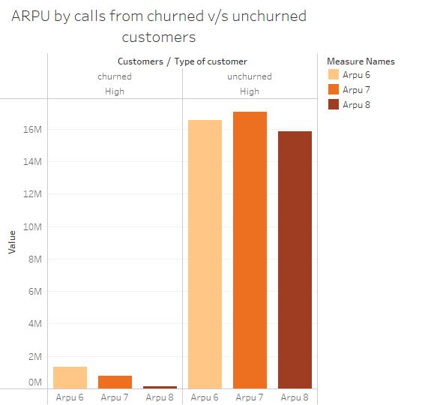

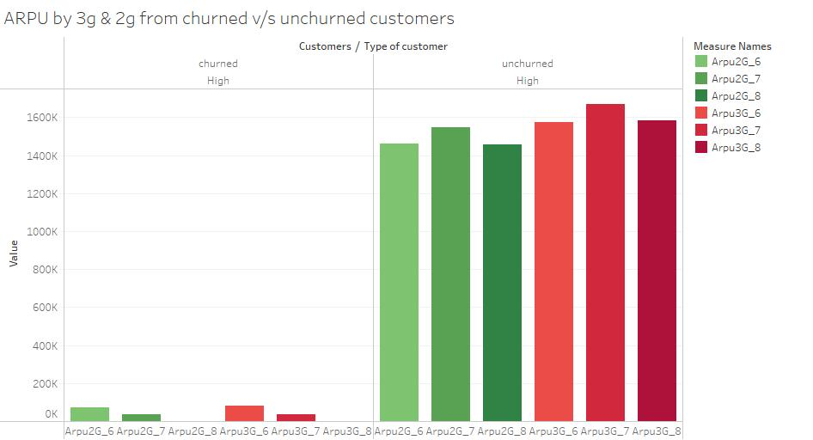

As per above graphs:

– **ARPU from calls by churned v/s unchurned customers**

– **ARPU from 3G & 2G internet by churned v/s unchurned customers**

The following observations are made

* Most of the revenue is generated by High valued unchurned customers.
* Customers using 3G internet generated more revenue in comparison to 2G users
* Revenue generated by calls is more as compared to Internet service.
* In the “Good phase” (6th & 7th month) the revenue generated is more as compared to “Action phase”, observed for both calls and internet services.

1. **Types of calls used by customers**

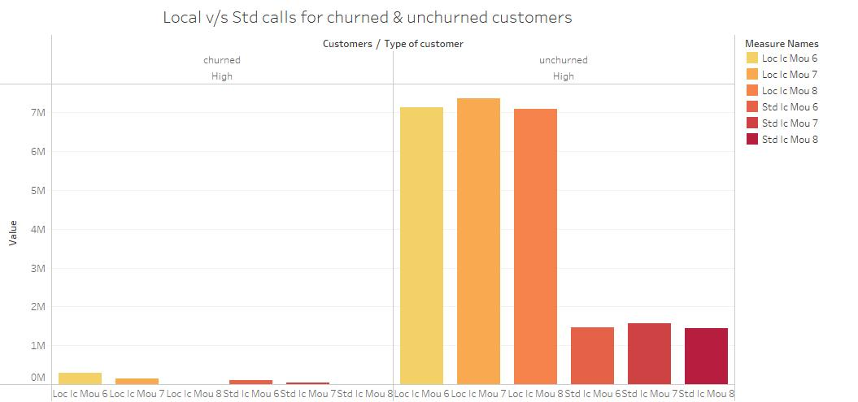

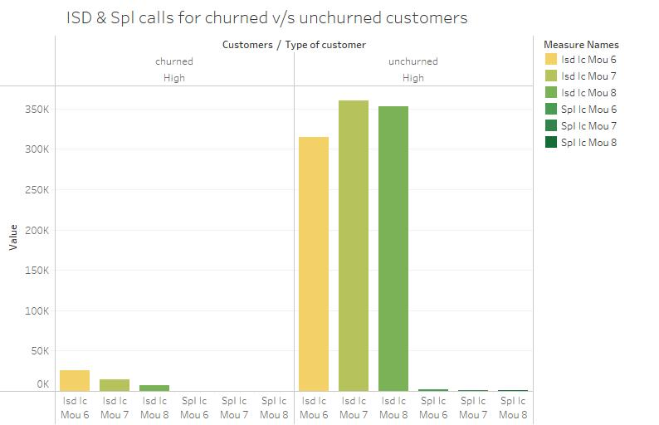

As per above graphs:

– **Local & STD calls by churned v/s unchurned customers**

– **ISD & Special calls by churned v/s unchurned customers**

The following observations are made

* Majorly 4 types of calls are used by customers i.e. Local, Standard, ISD & Special calls
* As observed the customers of this particular operator make more of Local calls
* In the “Good phase” (6th & 7th month) the calls made are more as compared to “Action phase” (8th month), observed for all types of calls.

1. **Incoming v/s Outgoing calls Minutes of usage**

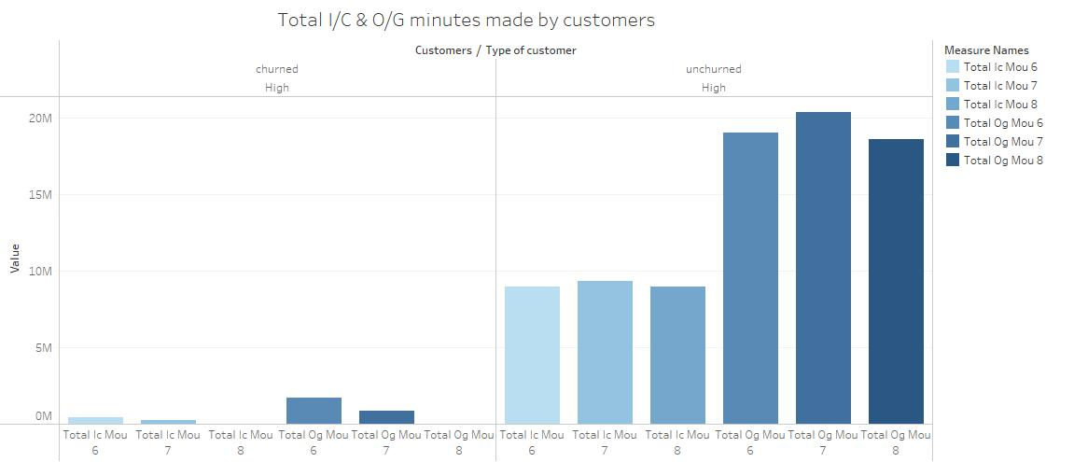

As per the graph:

– **Total Incoming & Outgoing minutes made by customers**

* Customers are using this network to make Outgoing calls in comparison to Incoming calls
* In the “Good phase” (6th & 7th month) the calls made are more as compared to “Action phase” (8th month), observed for both incoming and outgoing calls.

1. **Overall view of the churn and Customers –**

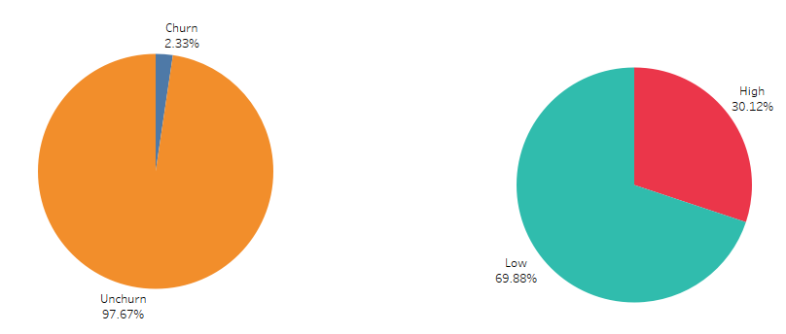

The total Churn – 2.33% The total High Value Customers – 30.12%

The total unchurn – 97.67% The total Low Value Customers – 69.88%

**B. Recommendations on the analyzed dataset –**

Recommendations are to provide the Recommendations for retaining the customers. Using Tableau final insights are generated to arrive at recommendation to retain the customers.

* Focus on the high value customers as they provide 80% of the business revenue, more importance to be given as of the above seen visualizations.
* More users make use of the local calls than comparatively to any other services.
* Making sure to contact the customers who are not actively using their service and finding out the reason.
* Majority of the services utilized was 3g when it comes to data as Facebook had started to spread all over as a trend among social media platform.
* An add on as customers expect their service provide to have an efficient network coverage, they also expect them to have a good customer service center where they can reach out to them at any time.